ISign Interface Specification

Department: | ZTE
Project name: | Isign
Document name: | Isign Interface Specification
Revision: | 1.0

09/2013
rEVISION
Date | Author | Task | Description | Version
12/09/2013 | Robby |  |  | 1.0
contents
1 INTRODUCTION 4
1.1 Interface description 4
1.2 Message flow 4
1.3 Authentication Parameters 5
1.4 Interface Parameters 6
1.5 Message Example 9
1.6 Code Example 9

INTRODUCTION
This document is intends to clarify the interface between OSS (Operation Support System) and Isign system.

Interface description
Interface uses https+json protocol, instead of using the username/password to access protected resources, the client need to obtain an access token using appkey and appsecret before calling Isign interface. We can regard appkey/appsecret as username/password.The following content will explain how to obtain access token. Isign will provider the following interface funcations:
Register service, Cancel service, Change signature,Suspend Service, Resume Service, Reject receiving signature, Active receiving signature.

Message flow
The message flow between OSS and Isign:
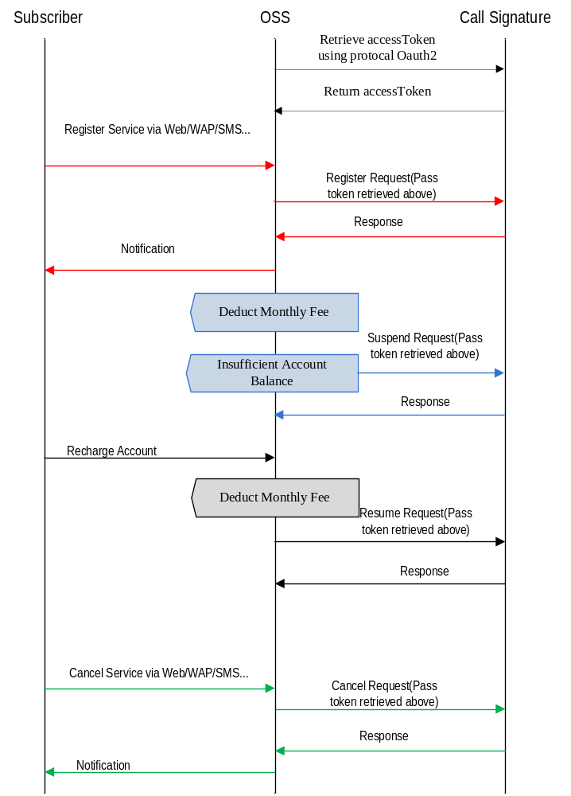

Authentication Parameters
Request URL：http://IP:Port/open/oauth/authorize.action
Http request method:POST
- Request
Parameter:
Element Name | Required | Description
client_id | true | app_key generated while app application
client_secret | true | app_secret generated while app application
grant_type | true | client_credentials
scope | flase | Authorization scope
Sample:
POST /token HTTP/1.1
Content-Type: application/x-www-form-urlencoded
grant_type=client_credentials&client_id=app_key&client_secret=app_secret
- Response
Parameter:
Element Name | Description
access_token | Used to access protected resource in call signature platform
expires_in | The expired time of access token(timestamp format of unix)
refresh_token | Refresh token(used to refresh access token if access token was expired)
state | If passed this parameter, we will return it again(OSS can use this parameter to authenticate server)

Interface Parameters
Request URL：https://IP:Port/csViettelSync.action?oauth_token=xxxxxx(Port is https port in SMC server)
Http request method:POST
Message Header:
SN | Element Name | Type | Length | Description | Sample
1 | versionCode | String | 4 | Protocol Version Code | 0100
2 | actionCode | String | 1 | Message Type | 0-Request，1-Response
3 | originTransID | String | 30 | Original Transaction ID | 100200030004
4 | destTransID | String | 30 | Destination Transaction ID | 211923399866

- Request
Message Body:
Element Name | Type | Length | Description | Sample
phoneNumber | String | <=18 | Mobile number (International format only) that need to register CS Service | 6618163336
triggerNumber | String | <=18 | Mobile number that help other to register | 6618163335
oprCode | String | 2 | Operation Code | 01 Service Register  02 Cancel Service  03 Suspend Service  04 Resume Service  05 Modify Signature  06 Reject receiving signature  07 Active receiving signature
tariffID | String | 4 | Tariff ID | Service package id defined in Cll Sgnature Sstem  (This parameter should support OprCode 01 and 05 ,06)
oprTime | String | 14 | Operation Time | YYYYMMDDHHMMSS
oprSrc | String | 2 | Operation Source | 01 Business Hall
 |  |  |  | 02 Call Center
 |  |  |  | 03 WAP Portal
 |  |  |  | 04 Administrator
 |  |  |  | 05 WEB Portal
 |  |  |  | 06 SMS
 |  |  |  | 07 Online Business Hall
 |  |  |  | 13 USSD
 |  |  |  | 20 Others
reason | String | 50 | Reason of Canceling
brandId | String | 2 | Brand Name | 0 = GSM  1 = 12CALL  4 = 3G-Postpaid  5 = 3G-Prepaid
 |  |  |  | This parameter is mandatory when oprCode = 01
paidMode | String | 2 | Paid Mode | Prepaid  Postpaid
signatureContent | String |  | Signature content of user(just support oprCode 05)
signaturePackageId | String |  | just support oprCode 05
paramList | - | - | Father element of ParamValue and ParamName. Many ParameterMap elements may exist or not exist in request body.
paramName | String | 128 |  | PreRegisterFlag
paramValue | String | 128 |  | 0：Normal Registered subscriber  1：Pre-Registered subscriber
- Response
SN | Element Name | Type | Length | Description | Sample
1 | rspCode | String | 4 | Operation Result | 0-Successful Operation  1001- Time Out  1002- Invalid User Number  1003- Decode Error
2 | rspDesc | String | 100 | Operation Result Description | Successful Operation

Message Example
Request：
{"header":{"versionCode":"1.1",” actionCode”:0,"originTransID":"20130713120000","destTransID":"123123"},
"body":{"phoneNumber":18800000000,"oprCode":"01",”oprSrc”:”01”,"tariffID":1012}}
Example for Query Information
Response：
{"header":{"actionCode":1,"destTransID":"20130713120000","originTransID":"201307191248237670002","versionCode":"1.1"},
"body":{"rspCode":"0","rspDesc":"Successful Operation"}

Code Example
